

**WEB TECHNOLOGY SCSJ3483 02**

Prof. Madya Dr. Yazid

Assignment 4

nAvi Team

Ahmad Firdaus Bin Abd Rashid

A18CS0013

1. Video Conference - Ahmad Firdaus

This is an assignment 4 where I need to use the Slim Framework as backend.

Here I use the methods which are PUT, DELETE, GET and POST.

|  |  |
| --- | --- |
| **Image Arrangement** | |
| 1. PUT/DELETE Method Display    * Image 1.4 2. PUT method code    * Image 1.9 3. DELETE method code    * Image 1.8 4. GET method display    * Image 1.1    * Image 1.3 5. GET method code    * Image 1.6    * Image 1.7 6. POST method display    * Image 1.5 7. POST method code    * Image 1.10    * Image 1.11 8. JavaScript code to fetch data 9. GET    * Image 1.12 10. POST from Form     * Image 1.13 | 1. Image 1.1 – display – GET method 2. Image 1.2 – Example database 3. Image 1.3 – display – GET method 4. Image 1.4 – display – PUT/DELETE method 5. Image 1.5 – display – POST method 6. Image 1.6 – code – GET method 7. Image 1.7 – code – GET method 8. Image 1.8 – code – DELETE method 9. Image 1.9 – code – PUT method 10. Image 1.10 – code – POST method 11. Image 1.11 – code – POST method 12. Image 1.12 – code – JavaScript GET 13. Image 1.13 – code – JavaScript POST form |

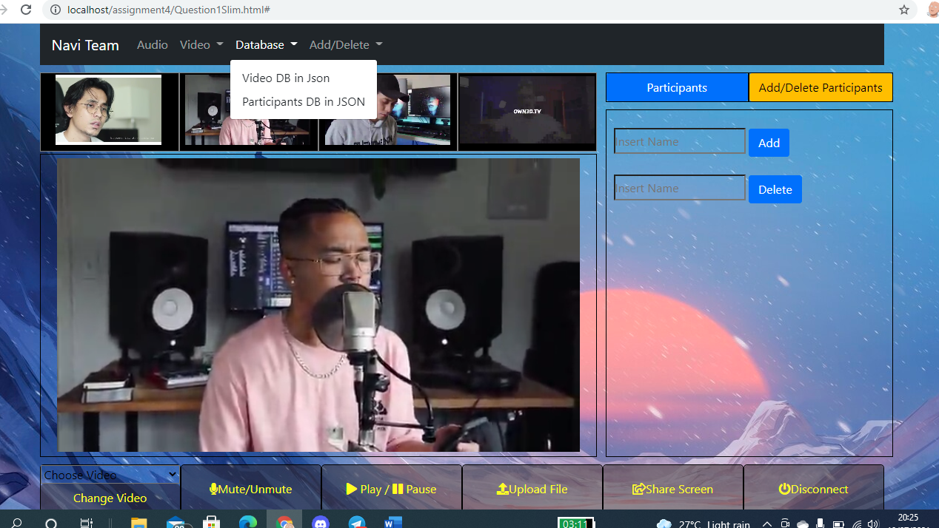

Image 1.1: Database navbar to see the database fetch from SLIM

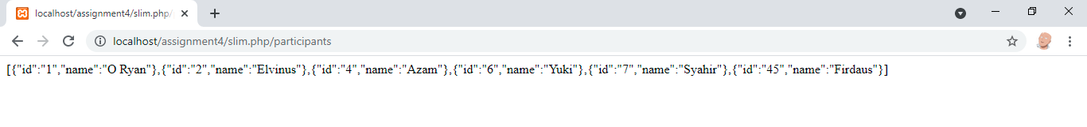

Image 1.2: I replace the name index.php to slim.php, Database data for GET method

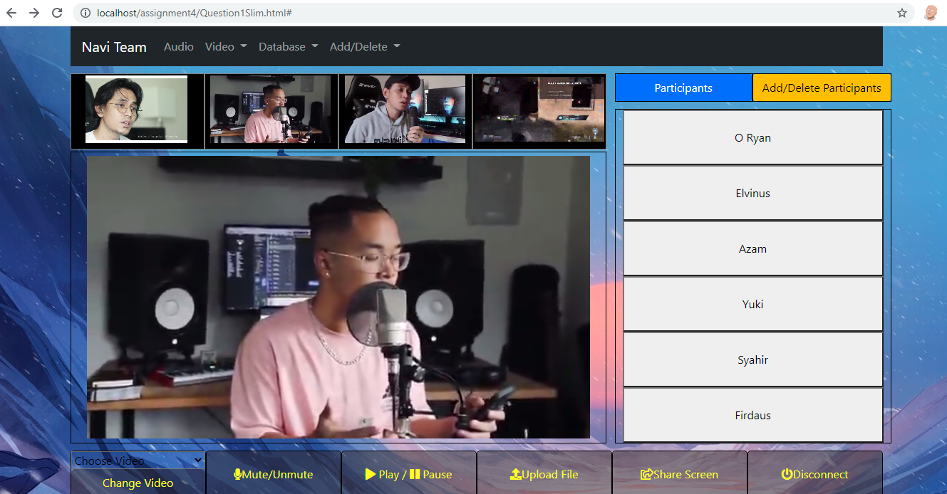

Image 1.3: All data fetch from slim.php

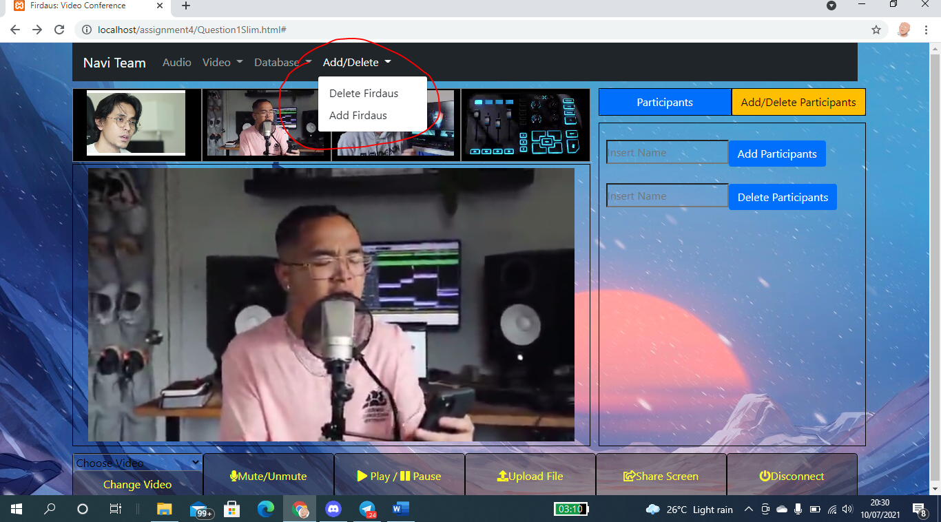

Image 1.4: Using navbar to add/delete Firdaus as participants using PUT/DELETE method

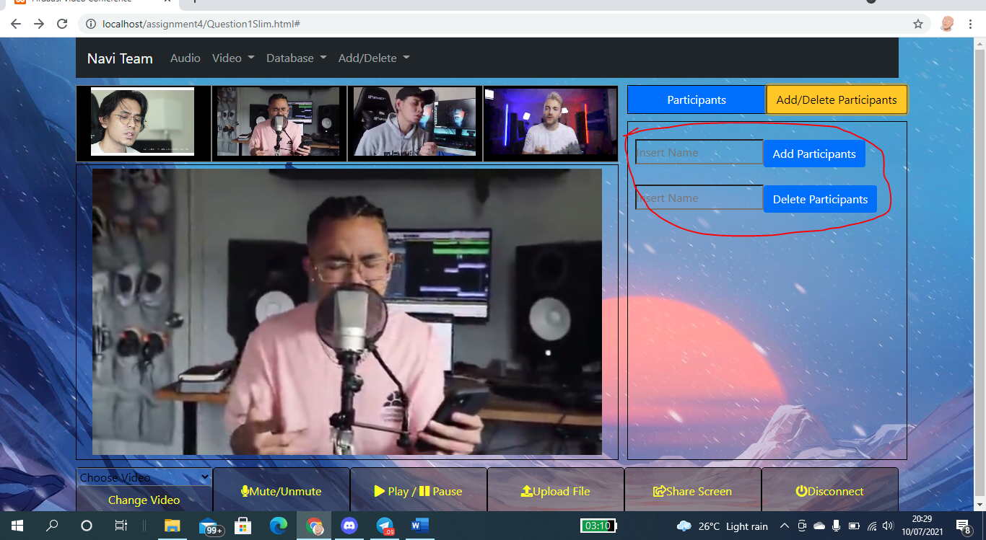

Image 1.5: Using POST method to insert and delete data from database

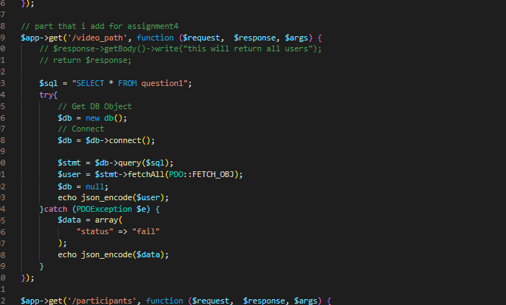

Image 1.6: GET method in SLIM to get video_path

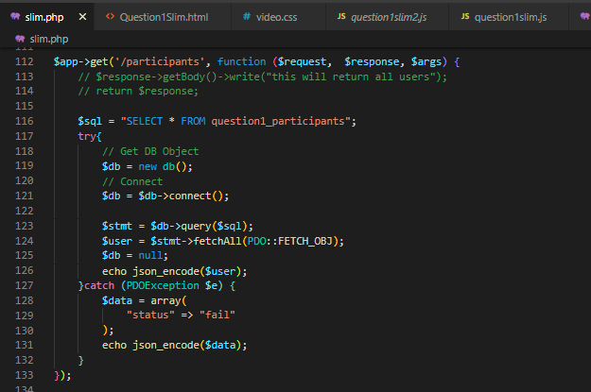



Image 1.7: GET method in SLIM to view all participants

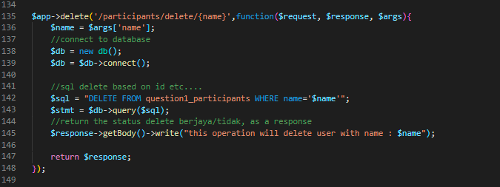

Image 1.8: DELETE method to delete a participant

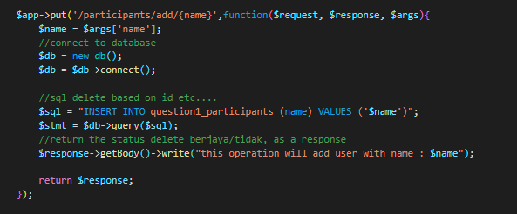

Image 1.9: PUT method to add participants

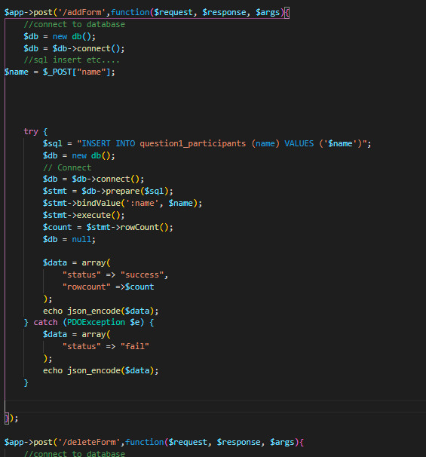

Image 1.10: POST method to add participants

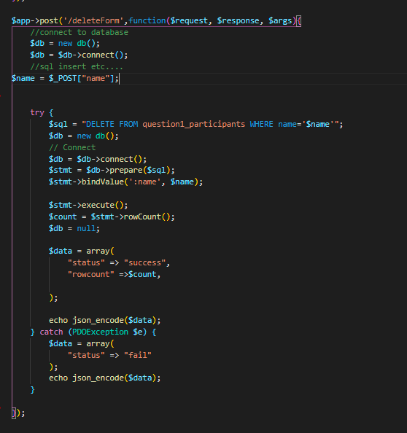

Image 1.11: POST method to delete participants

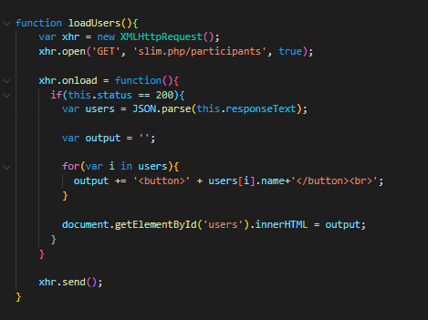

Image 1.12: using JavaScript to call slim framework, GET method

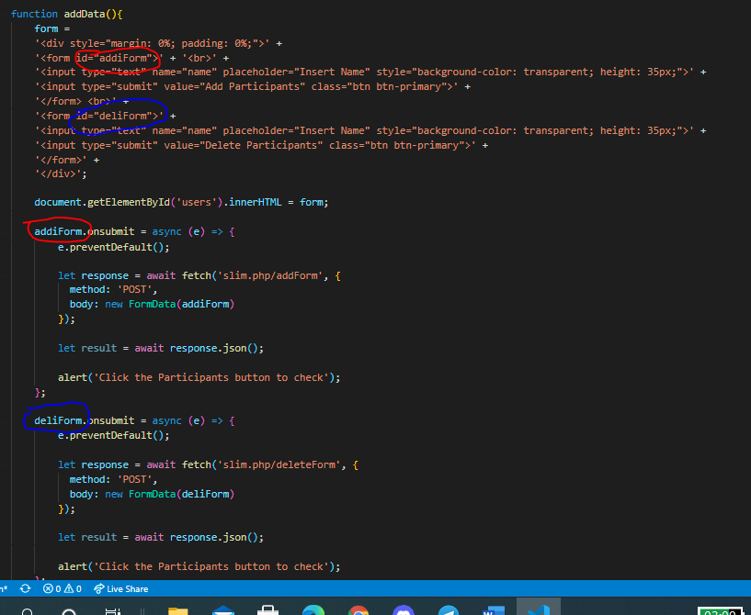

Image 1.13: use JavaScript to manipulate html file, and use form to send POST data